Melting observations
1. Candles are made from wax.
Heating pure wax can make it melt.
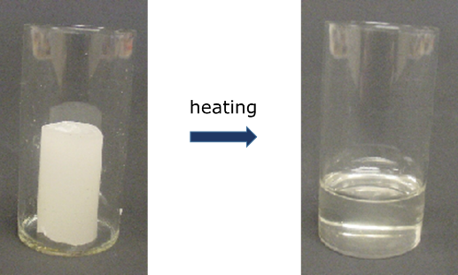
The melting point of pure wax is 67ºC.
At what temperature does the wax start to melt?
A Around 60°C
B 65°C
C 67°C
D 69°C

2. Lead is a type of metal.
Heating lead can make it melt.
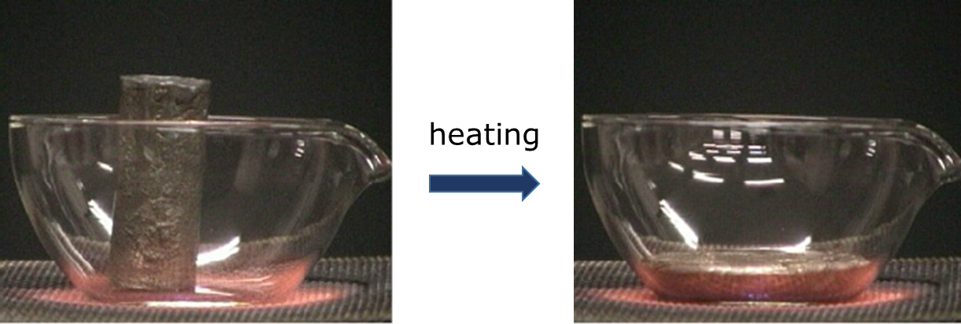
Lead starts to melt at 327ºC.
What is the temperature of lead when the last bit melts?
A 327°C
B 328°C
C 329°C
D 332°C
Chemistry > Big idea CSU: Substances and properties > Topic CSU1: Substances and mixtures > Key concept CSU1.1: Substance
Diagnostic question
Melting observations

Overview
Learning focus: | A chemical substance has a characteristic melting and boiling point and can exist in different states.
Observable learning outcome: | Match observations of melting (or cooling) to the temperature at which they take place.
Question type: | Simple multiple choice
Key words: | solid, liquid, state, melting point, temperature

What does the research say?
Johnson and Papageorgiou (2010) used questions to explore students’ understanding of macroscopic observations of melting in relation to melting point. Students with a sound understanding understood that melting point was the divide between the solid and liquid states and that a substance would show no signs of melting below the melting point or of solidifying above this temperature whilst cooling.
However, some students considered melting point to be the start or end of a narrow zone over which melting, or solidification occurred.
Ways to use this question
Students should complete the question individually. This could be a pencil and paper exercise, or you could use an electronic ‘voting system’ or mini white boards and the PowerPoint presentation.
The answers to the question will show you whether students understood the concept sufficiently well to apply it correctly.
If there is a range of answers, you may choose to respond through structured class discussion. Ask one student to explain why they gave the answer they did; ask another student to explain why they agree with them; ask another to explain why they disagree, and so on. This sort of discussion gives students the opportunity to explore their thinking and for you to really understand their learning needs.
Differentiation
Some students may benefit from being able to actually observe the melting process taking place. This could be easily carried out using an ice cube in a beaker with the questions adapted for a melting point of 0°C.
Expected answers
1 C 2A

How to respond - what next?
Question 1 addresses the idea that the melting point is the temperature at which melting starts. Thinking there is a range and a lead in to ‘proper’ melting, some students may choose either option A or B. Few if any will choose D which is offered for completeness.

Question 2 focuses on the temperature while melting take place. The highest temperature, option C, is likely to be the most popular choice as students may think that the temperature of the lead continues to rise during melting (which it does not).

A good response to finding a misunderstanding, could be to teach the idea to the class and then give the students an activity in which they can practise using the concept so that they can consolidate their understanding. Responses often work best when the activities involve paired or small group discussions, which encourage social construction of new ideas through dialogue. In this case, students could also try the ‘cooling observations’ diagnostic question to explore the relationship between melting point and solidification.
If students have misunderstandings about melting point they may be considering an everyday encounter with melting, for example chocolate. Students should be reminded that chocolate is actually a mixture and that melting points are given for pure samples of a substance. A fuller explanation in terms of particles is explored in the key concept CPS4.1: Explaining shape of change of state graphs.
The following BEST ‘response activity’ could be used in follow-up to this diagnostic question:
- Comparing melting
Acknowledgments
Developed by Helen Harden (UYSEG), from a York Science question devised by Andrew Hunt.
The questions were selected from a collection of ASK questions devised for research by Philip Johnson.
Images: Philip Johnson.
References
Johnson, P. and Papageorgiou, G. (2010). Rethinking the Introduction of Particle Theory: A Substance-based framework. Journal of Research in Science Teaching. 42(2) 130-150
Johnson, P. (2012). Introducing particle theory. In Taber, K. (ed.) ASE Science Practice: Teaching Secondary Chemistry. New edition ed. London: Hodder Education.

